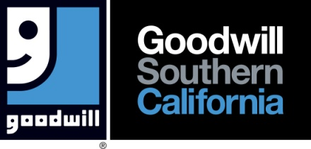

FOR IMMEDIATE RELEASE

**Media Contacts:**

Marla Eby – Director, Marketing & Media Relations - Goodwill Southern California

(323) 539-2104 [meby@goodwillsocal.org](mailto:meby@goodwillsocal.org)

**FOR IMMEDIATE RELEASE**

**CityBoyz Givebacks Joins Forces with Goodwill SoCal To Hold Community Drive At Goodwill SoCal LA Campus**

Los Angeles, CA, December 9, 2024 – CityBoyz Givebacks, a grassroots non-profit organization dedicated to bettering the community through service initiatives is partnering with Goodwill SoCal to hold their 5th Annual Holiday Community Drive from 10am – 1pm on Saturday, December 14 at Goodwill Southern California’s Los Angeles campus in Lincoln Heights.(342 N. San Fernando Rd. LA 90031).

What: 2024 CityBoyz Givebacks Goodwill SoCal Community Drive!

When: Saturday, December 14, 2024 10am – 1pm. Distribution of food & goods – 11am – 1pm.

Where: Goodwill SoCal’s LA Campus 342 N. San Fernando Dr. LA 90031 (Lincoln Heights)

Why: Impact the unhoused and underprivileged communities of LA.

Details: Food & clothing donation drive, backpack giveaway. Haircuts, employment services& more.

Together, we’re committed to uplifting families and individuals across our community by providing essentials like food, clothing, health services, and employment resources. Thanks to partners, each year’s drive grows, bringing more comfort and hope to our neighbors when they need it most. For more information, or to volunteer, visit [www.cityboyzgivebacks.org](http://www.cityboyzgivebacks.org)

**About CityBoyz Givebacks**

CityBoyz Givebacks was founded out of love with a desire the give back to the community. The organization, with strong roots in LA, orchestrates food and clothing drives for the homeless community and those who are less fortunate to ease the struggles that they may face in their everyday lives. For more information, or to volunteer, visit [www.cityboyzgivebacks.org](http://www.cityboyzgivebacks.org)

**About Goodwill Southern California**

Transforming lives through the power of work, Goodwill Southern California (GSC) serves individuals with barriers to employment by providing education, training, work experience and job placement services.  Each year, GSC prepares and places thousands of individuals into sustainable employment through programs and services offered at three campuses as well as Career Resource Centers, WorkSource Centers, Youth and Veteran Employment Programs throughout Los Angeles (north of Rosecrans Ave.), Riverside and San Bernardino counties.  GSC supports its mission with proceeds generated from more than 80 stores and additional freestanding attended donation centers.  GSC spends 95 percent of its budget on programs and services.  Committed to caring for the earth, last year GSC diverted over 130 million pounds of reusable or recyclable goods from landfills. Follow Goodwill SoCal on social media - @GoodwillSoCal or visit [www.goodwillsocal.org](http://www.goodwillsocal.org) for more information.

###